1.INVENTORY MANAGEMENT SYSTEM
import java.util.HashMap;
import java.util.Scanner;

class Product {
String productId;
String productName;
int quantity;
double price;

public Product(String productId, String productName, int quantity, double price) {
this.productId = productId;
this.productName = productName;
this.quantity = quantity;
this.price = price;
}

public String toString() {
return "ID: " + productId + ", Name: " + productName + ", Qty: " + quantity + ", Price: " + price;
}
}

public class InventorySystem {
static HashMap<String, Product> inventory = new HashMap<>();

public static void addProduct(Product product) {
inventory.put(product.productId, product);
System.out.println("Product added.");
}

public static void updateProduct(String productId, int newQty, double newPrice) {
if (inventory.containsKey(productId)) {
Product p = inventory.get(productId);
p.quantity = newQty;
p.price = newPrice;
System.out.println("Product updated.");
} else {
System.out.println("Product not found.");
}
}

public static void deleteProduct(String productId) {
if (inventory.remove(productId) != null) {
System.out.println("Product removed.");
} else {
System.out.println("Product not found.");
}
}

public static void displayInventory() {
if (inventory.isEmpty()) {
System.out.println("Inventory is empty.");
return;
}
for (Product p : inventory.values()) {
System.out.println(p);
}
}

public static void main(String[] args) {
Scanner sc = new Scanner(System.in);
while (true) {
System.out.println(" 1.Add 2.Update 3.Delete 4.Display 5.Exit ");
int choice = sc.nextInt();
sc.nextLine();
switch (choice) {
case 1:
System.out.print("Product ID: ");
String id = sc.nextLine();
System.out.print("Name: ");
String name = sc.nextLine();
System.out.print("Quantity: ");
int qty = sc.nextInt();
System.out.print("Price: ");
double price = sc.nextDouble();
addProduct(new Product(id, name, qty, price));
break;
case 2:
System.out.print("Enter Product ID to update: ");
String upId = sc.nextLine();
System.out.print("New Quantity: ");
int upQty = sc.nextInt();
System.out.print("New Price: ");
double upPrice = sc.nextDouble();
updateProduct(upId, upQty, upPrice);
break;
case 3:
System.out.print("Enter Product ID to delete: ");
String delId = sc.nextLine();
deleteProduct(delId);
break;
case 4:
displayInventory();
break;
case 5:
System.out.println("Exiting...");
return;
}
}
}
}

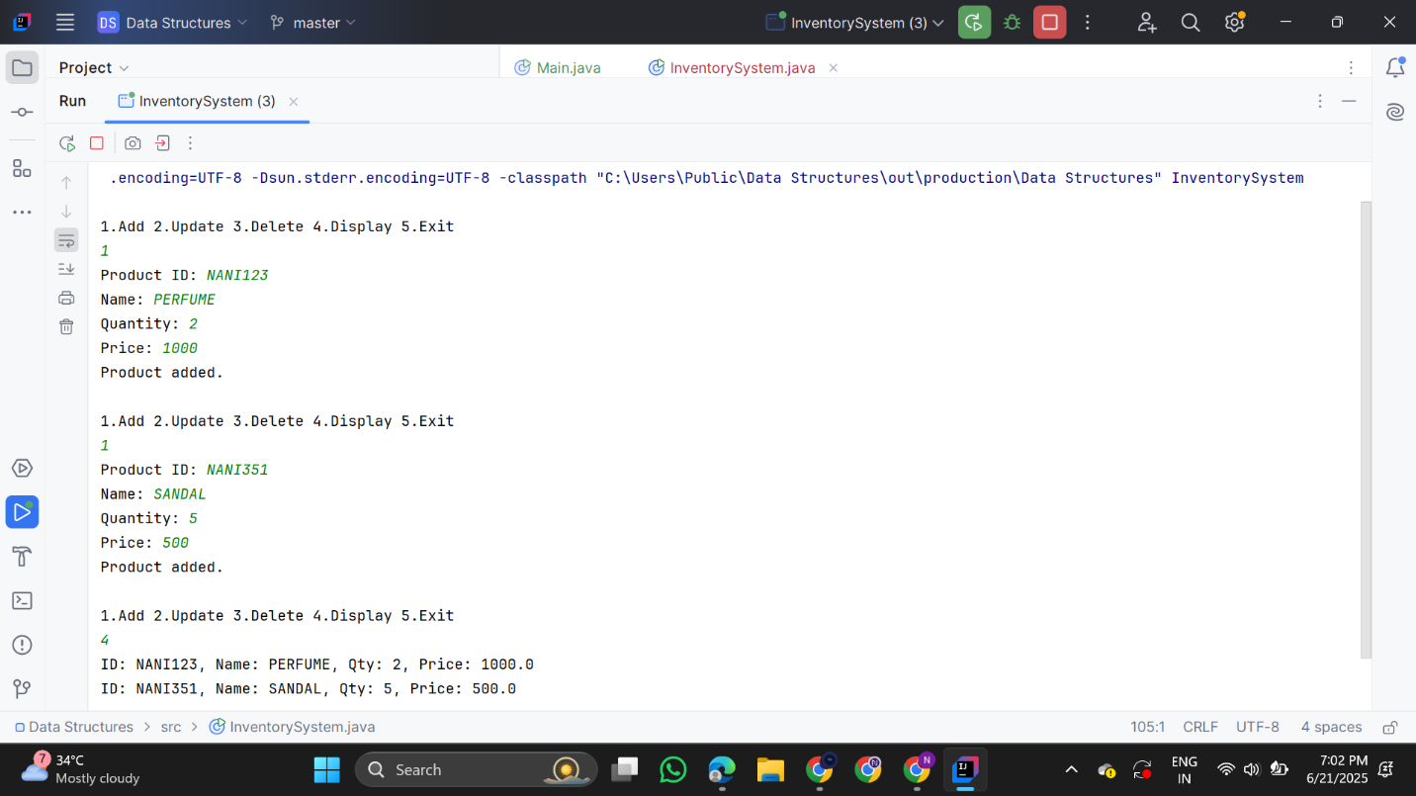

2. E-commerce Platform Search Function

import java.util.*;

class Item {
String productId, productName, category;

public Item(String productId, String productName, String category) {
this.productId = productId;
this.productName = productName;
this.category = category;
}

public String toString() {
return "ID: " + productId + ", Name: " + productName + ", Category: " + category;
}
}

public class ECommerceSearch {

public static Item linearSearch(Item[] items, String targetName) {
for (Item i : items) {
if (i.productName.equalsIgnoreCase(targetName)) return i;
}
return null;
}

public static Item binarySearch(Item[] items, String targetName) {
Arrays.sort(items, Comparator.comparing(i -> i.productName.toLowerCase()));
int left = 0, right = items.length - 1;
while (left <= right) {
int mid = left + (right - left) / 2;
int cmp = items[mid].productName.compareToIgnoreCase(targetName);
if (cmp == 0) return items[mid];
else if (cmp < 0) left = mid + 1;
else right = mid - 1;
}
return null;
}

public static void main(String[] args) {
Item[] items = {
new Item("P001", "Laptop", "Electronics"),
new Item("P002", "Shoes", "Fashion"),
new Item("P003", "Book", "Education"),
new Item("P004", "Smartphone", "Electronics"),
new Item("P005", "Pen", "Stationery")
};

Scanner sc = new Scanner(System.in);
System.out.print("Enter product name to search: ");
String input = sc.nextLine();

System.out.println(" Linear Search: ");
Item linearResult = linearSearch(items, input);
System.out.println(linearResult != null ? linearResult : "Item not found.");

System.out.println(" Binary Search: ");
Item binaryResult = binarySearch(items, input);
System.out.println(binaryResult != null ? binaryResult : "Item not found.");

}

}

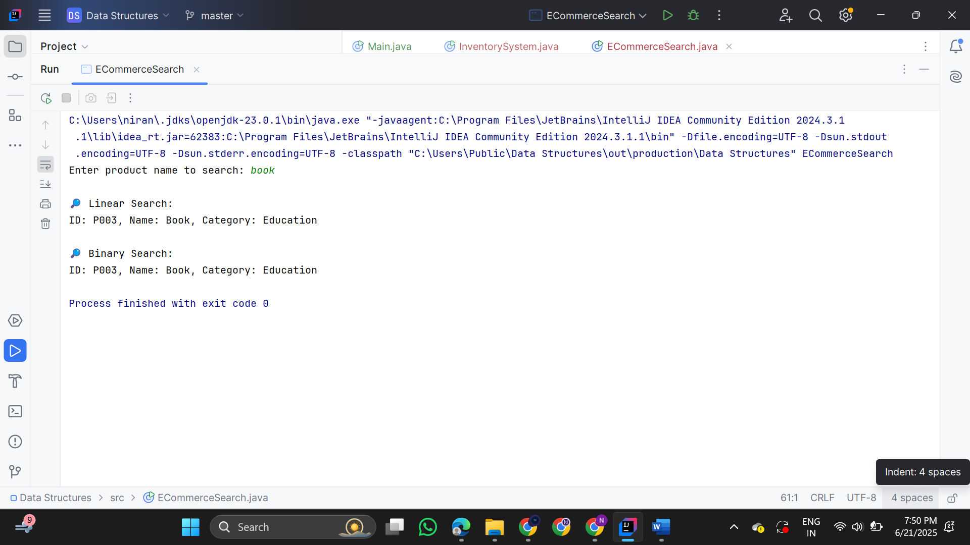

3.Sorting Customer Orders
import java.util.*;

class Order {
String orderId;
String customerName;
double totalPrice;

public Order(String orderId, String customerName, double totalPrice) {
this.orderId = orderId;
this.customerName = customerName;
this.totalPrice = totalPrice;
}

public String toString() {
return "OrderID: " + orderId + ", Customer: " + customerName + ", Total: ₹" + totalPrice;
}
}

public class OrderSorter {

public static void bubbleSort(Order[] orders) {
int n = orders.length;
for (int i = 0; i < n - 1; i++) {
for (int j = 0; j < n - i - 1; j++) {
if (orders[j].totalPrice < orders[j + 1].totalPrice) {
Order temp = orders[j];
orders[j] = orders[j + 1];
orders[j + 1] = temp;
}
}
}
}

public static void quickSort(Order[] orders, int low, int high) {
if (low < high) {
int pi = partition(orders, low, high);
quickSort(orders, low, pi - 1);
quickSort(orders, pi + 1, high);
}
}

public static int partition(Order[] orders, int low, int high) {
double pivot = orders[high].totalPrice;
int i = low - 1;
for (int j = low; j < high; j++) {
if (orders[j].totalPrice > pivot) {
i++;
Order temp = orders[i];
orders[i] = orders[j];
orders[j] = temp;
}
}
Order temp = orders[i + 1];
orders[i + 1] = orders[high];
orders[high] = temp;
return i + 1;
}

public static void printOrders(Order[] orders) {
for (Order o : orders) {
System.out.println(o);
}
}

public static void main(String[] args) {
Order[] orders = {
new Order("O001", "Alice", 1500.0),
new Order("O002", "Bob", 3000.0),
new Order("O003", "Charlie", 2000.0),
new Order("O004", "David", 500.0),
new Order("O005", "Eve", 4000.0)
};

System.out.println(" Bubble Sort (by totalPrice):");
bubbleSort(orders);
printOrders(orders);

// Resetting orders for next test
orders = new Order[]{
new Order("O001", "Alice", 1500.0),
new Order("O002", "Bob", 3000.0),
new Order("O003", "Charlie", 2000.0),
new Order("O004", "David", 500.0),
new Order("O005", "Eve", 4000.0)
};

System.out.println(" Quick Sort (by totalPrice): ");
quickSort(orders, 0, orders.length - 1);
printOrders(orders);
}
}

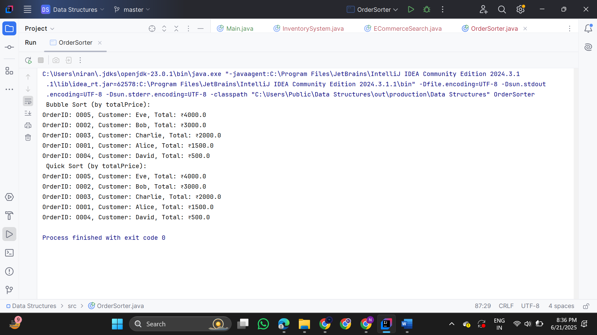

4.Employee Management System

Employee.java
public class Employee {
String employeeId;
String name;
String position;
double salary;

public Employee(String employeeId, String name, String position, double salary) {
this.employeeId = employeeId;
this.name = name;
this.position = position;
this.salary = salary;
}

public String toString() {
return "ID: " + employeeId + ", Name: " + name + ", Position: " + position + ", Salary: ₹" + salary;
}
}
EmployeeManagementSystem.java
import java.util.Scanner;

public class EmployeeManagementSystem {
static final int MAX = 100; // Max employees
static Employee[] employees = new Employee[MAX];
static int count = 0;
public static void addEmployee(Employee emp) {
if (count < MAX) {
employees[count++] = emp;
System.out.println("Employee added.");
} else {
System.out.println("Employee list is full!");
}
}
public static Employee searchEmployee(String id) {
for (int i = 0; i < count; i++) {
if (employees[i].employeeId.equalsIgnoreCase(id)) {
return employees[i];
}
}
return null;
}
public static void displayAll() {
if (count == 0) {
System.out.println("No employees found.");
return;
}
for (int i = 0; i < count; i++) {
System.out.println(employees[i]);
}
}
public static void deleteEmployee(String id) {
for (int i = 0; i < count; i++) {
if (employees[i].employeeId.equalsIgnoreCase(id)) {
for (int j = i; j < count - 1; j++) {
employees[j] = employees[j + 1]; // shift left
}
employees[--count] = null; // remove last duplicate
System.out.println("Employee deleted.");
return;
}
}
System.out.println("Employee not found.");
}
public static void main(String[] args) {
Scanner sc = new Scanner(System.in);
while (true) {
System.out.println("\n1.Add 2.Search 3.Display All 4.Delete 5.Exit");
int choice = sc.nextInt();
sc.nextLine(); // Consume newline
switch (choice) {

case 1:
System.out.print("ID: ");
String id = sc.nextLine();
System.out.print("Name: ");
String name = sc.nextLine();
System.out.print("Position: ");
String pos = sc.nextLine();
System.out.print("Salary: ");
double sal = sc.nextDouble();
addEmployee(new Employee(id, name, pos, sal));
break;

case 2:
System.out.print("Enter ID to search: ");
String searchId = sc.nextLine();
Employee emp = searchEmployee(searchId);
System.out.println(emp != null ? emp : "Employee not found.");
break;
case 3:
displayAll();
break;
case 4:
System.out.print("Enter ID to delete: ");
String delId = sc.nextLine();
deleteEmployee(delId);
break;
case 5:
System.out.println("Exiting...");
return;

}
}
}
}

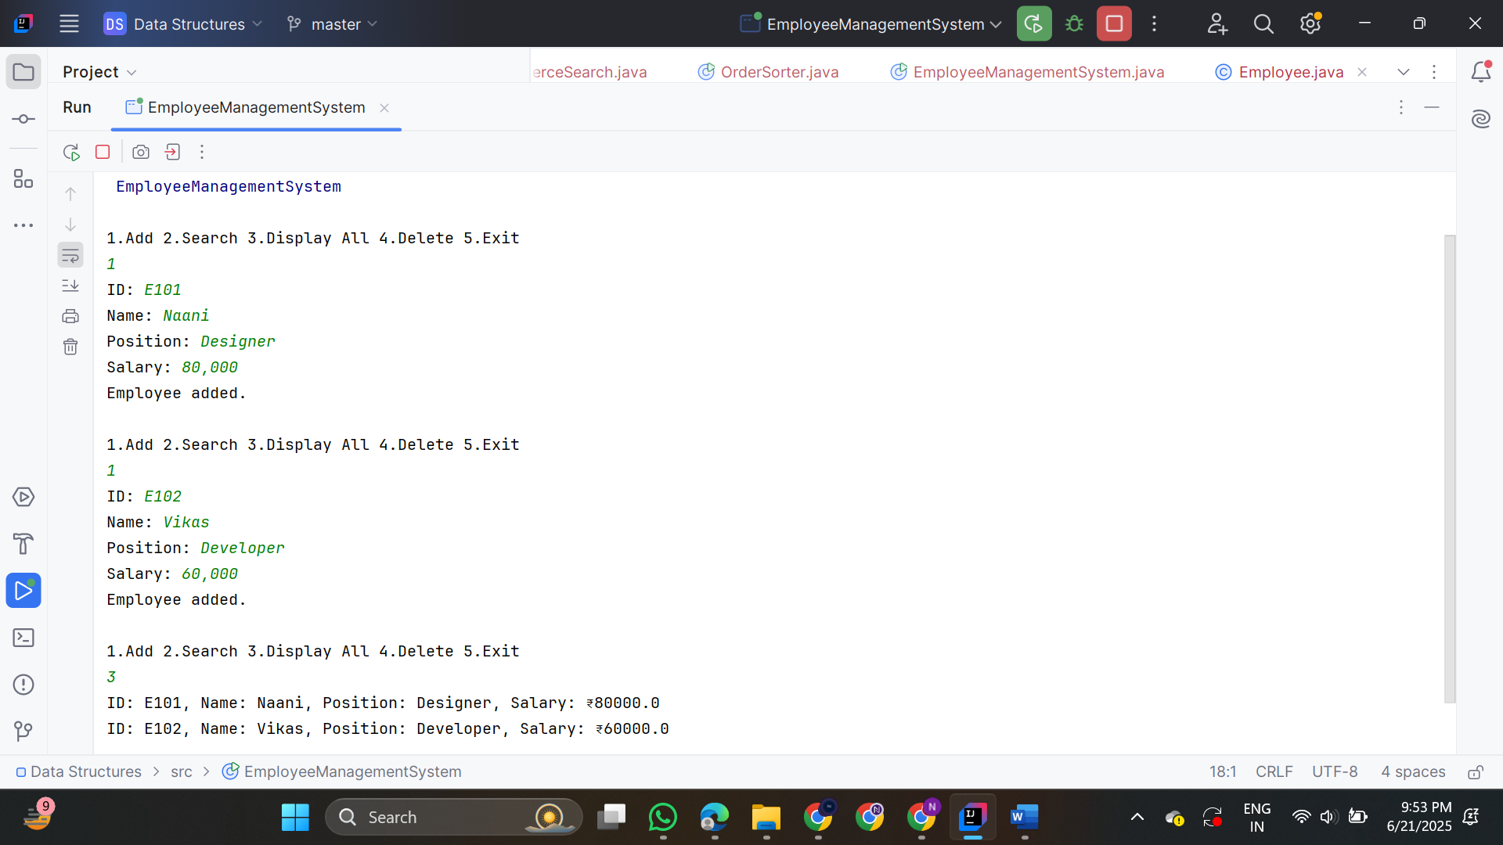

5. Task Management System
Task.java
class Task {
String taskId;
String taskName;
String status;

Task next;

public Task(String taskId, String taskName, String status) {
this.taskId = taskId;
this.taskName = taskName;
this.status = status;
this.next = null;
}

public String toString() {
return "Task ID: " + taskId + ", Name: " + taskName + ", Status: " + status;
}
}
TaskManager.java
public class TaskManager {
static Task head = null;

public static void addTask(Task newTask) {
if (head == null) {
head = newTask;
} else {
Task current = head;
while (current.next != null) {
current = current.next;
}
current.next = newTask;
}
System.out.println("Task added.");
}

public static Task searchTask(String taskId) {
Task current = head;
while (current != null) {
if (current.taskId.equalsIgnoreCase(taskId)) {
return current;
}
current = current.next;
}
return null;
}

public static void displayTasks() {
if (head == null) {
System.out.println("No tasks available.");
return;
}
Task current = head;
while (current != null) {
System.out.println(current);
current = current.next;
}
}
public static void deleteTask(String taskId) {
if (head == null) {
System.out.println("Task list is empty.");
return;
}
if (head.taskId.equalsIgnoreCase(taskId)) {
head = head.next;
System.out.println("Task deleted.");
return;
}
Task prev = head;
Task current = head.next;
while (current != null) {
if (current.taskId.equalsIgnoreCase(taskId)) {
prev.next = current.next;
System.out.println("Task deleted.");
return;
}
prev = current;
current = current.next;
}
System.out.println("Task not found.");
}
public static void main(String[] args) {
Scanner sc = new Scanner(System.in);
while (true) {
System.out.println(“ 1.Add Task 2.Search Task 3.Display All 4.Delete Task 5.Exit");
int choice = sc.nextInt();
sc.nextLine();
switch (choice) {
case 1:
System.out.print("Task ID: ");
String id = sc.nextLine();
System.out.print("Task Name: ");
String name = sc.nextLine();
System.out.print("Status: ");
String status = sc.nextLine();
addTask(new Task(id, name, status));
break;
case 2:
System.out.print("Enter Task ID to search: ");
String searchId = sc.nextLine();
Task found = searchTask(searchId);
System.out.println(found != null ? found : "Task not found.");
break;
case 3:
displayTasks();
break;
case 4:
System.out.print("Enter Task ID to delete: ");
String delId = sc.nextLine();
deleteTask(delId);
break;
case 5:
System.out.println("Exiting...");
return;
}
}
}
}
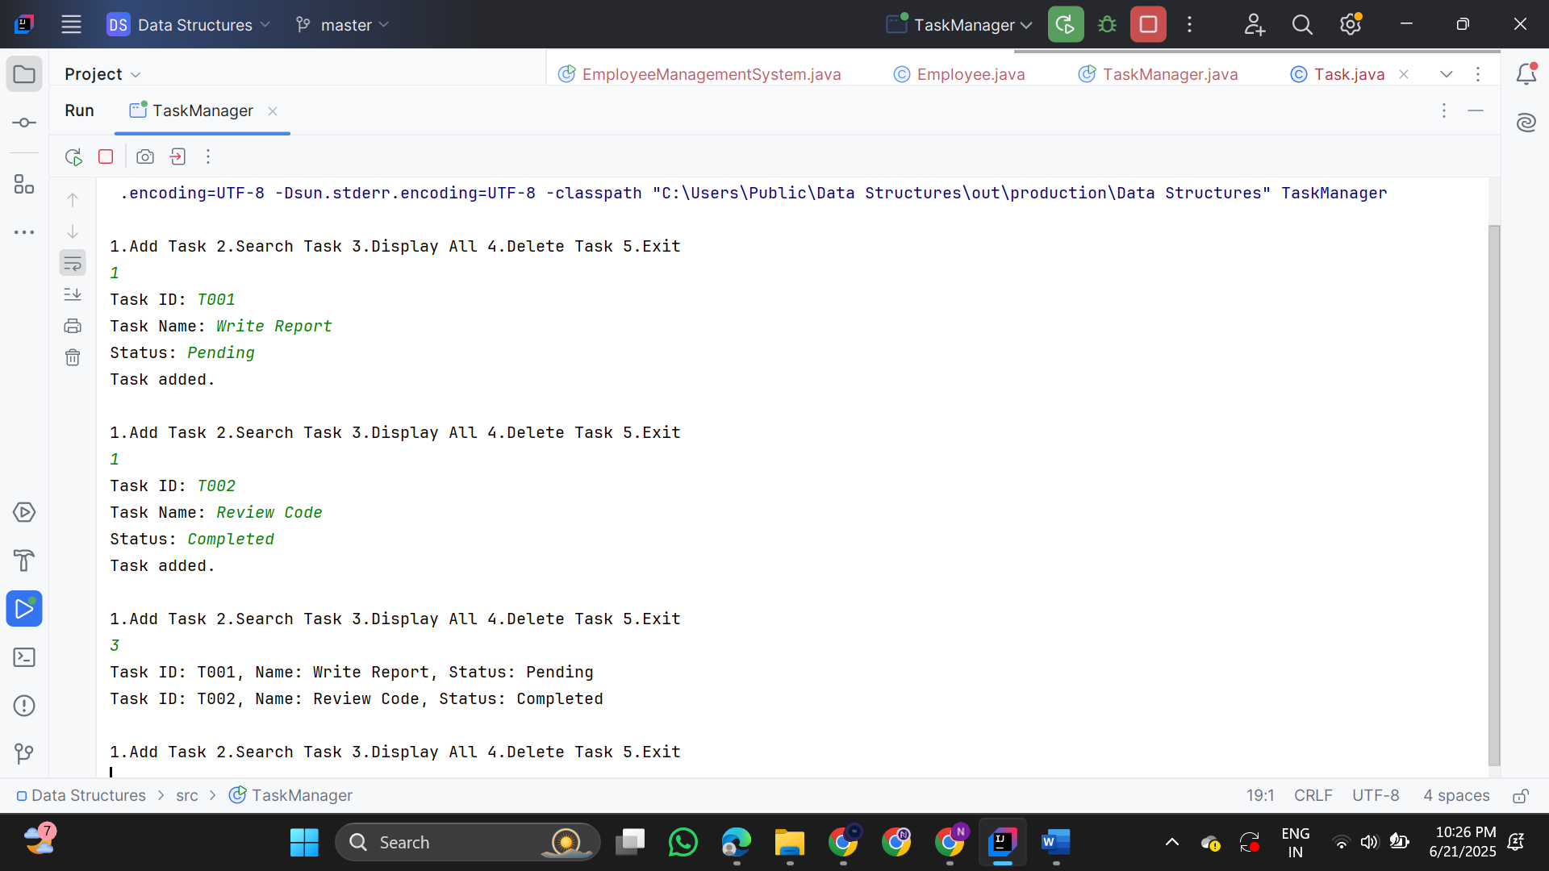

6.Library Management System

class Book {
String bookId, title, author;

public Book(String bookId, String title, String author) {
this.bookId = bookId;
this.title = title;
this.author = author;
}

public String toString() {
return "ID: " + bookId + ", Title: " + title + ", Author: " + author;
}
}

public class LibrarySearch {

public static Book linearSearch(Book[] books, String targetTitle) {
for (Book b : books) {
if (b.title.equalsIgnoreCase(targetTitle)) {
return b;
}
}
return null;

}
public static Book binarySearch(Book[] books, String targetTitle) {
Arrays.sort(books, Comparator.comparing(b -> b.title.toLowerCase()));
int left = 0, right = books.length - 1;
while (left <= right) {
int mid = left + (right - left) / 2;
int cmp = books[mid].title.compareToIgnoreCase(targetTitle);
if (cmp == 0)
return books[mid];
else if (cmp < 0)
left = mid + 1;
else
right = mid - 1;
}
return null;
}

public static void main(String[] args) {
Book[] books = {
new Book("B101", "Java Basics", "Nisha Sharma"),
new Book("B102", "Data Structures", "Ravi Kumar"),
new Book("B103", "Operating Systems", "Anita Desai"),
new Book("B104", "Algorithms", "Ashok Mehta"),
new Book("B105", "Networking", "Ramesh Iyer")
};

Scanner sc = new Scanner(System.in);
System.out.print("Enter book title to search: ");
String input = sc.nextLine();

System.out.println(" Linear Search:");
Book result1 = linearSearch(books, input);
System.out.println(result1 != null ? result1 : "Book not found.");

System.out.println(" Binary Search:");
Book result2 = binarySearch(books, input);
System.out.println(result2 != null ? result2 : "Book not found.");
}
}

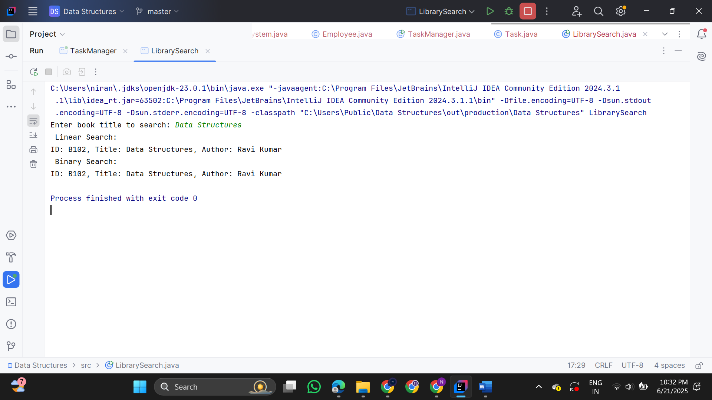

7. FinancialForecast

public class FinancialForecast {
public static double forecast(double initialValue, double rate, int years) {
if (years == 0) {
return initialValue; }
return forecast(initialValue, rate, years - 1) * (1 + rate);
}
public static void main(String[] args) {
double initialValue = 1000.0;
double growthRate = 0.10;
int years = 5;
double futureValue = forecast(initialValue, growthRate, years);
System.out.printf("Future Value after %d years: ₹%.2f", years, futureValue); }}
